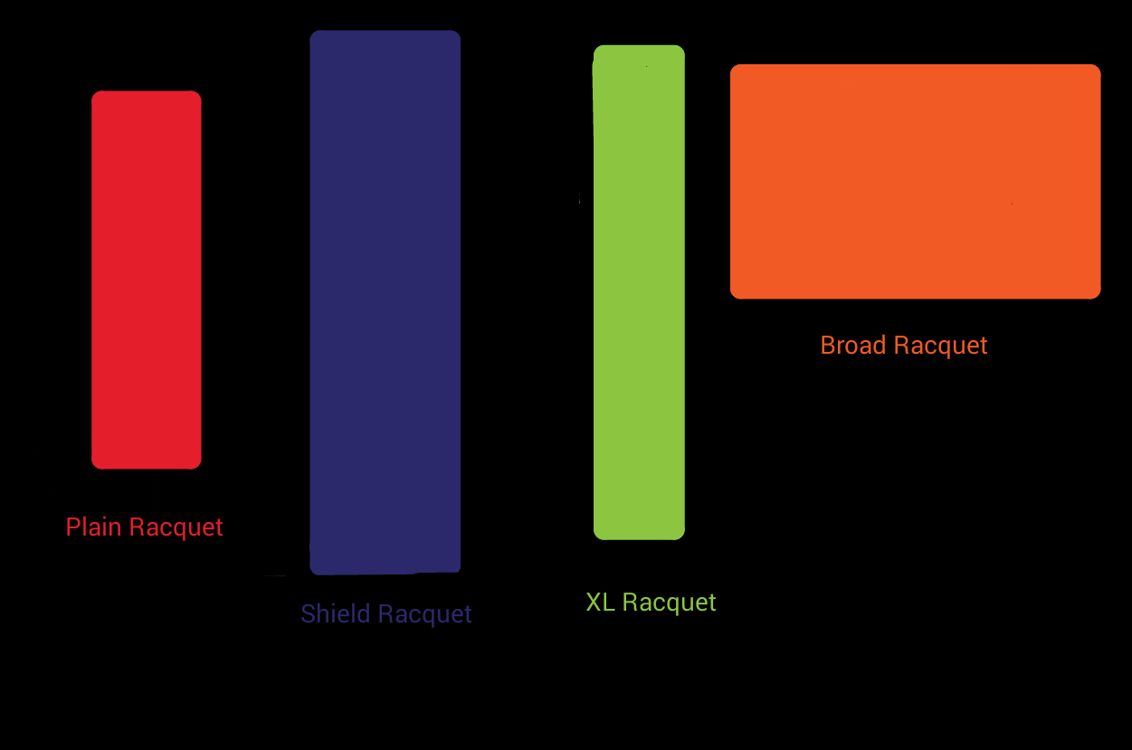

Plain Racquet – Acts at the normal racquet for the game, will bounce off all balls at a constant speed, except Super Pin

Shield – Is a giant impenetrable racquet that can return anything even the Super Pin

XL Racquet – Inherits from Plain Racquet. Its length is double that of the Plain Racquet, will be broken if hit by Super Pin Ball. If player gets scored on, will revert back to Plain Racquet

Broad Racquet – Inherits from Plain Racquet. Its width is double that of the Plain Racquet (length is also slightly greater) will be broken if hit by Super Pin Ball but will return it. If player is scored on it will revert back to Plain Racquet